Code based migration

1. When we want more control on migration
2. Allows you to configure additional things

Commands

1. Enable migration => Creating configuration class
2. Add Migration => UP() and DOWN() method
3. Update database =>in add migration whatever we have done applies to database(based on the updates)

* Can use verbose to see the execution of statements

Step1:

Create console application

install-package entityframework -version 6.2

Singers.cs

using System;

using System.Collections.Generic;

using System.Linq;

using System.Text;

using System.Threading.Tasks;

namespace ManualMigration

{

class Singers

{

public int SingersId { get; set; }

public string Singername { get; set; }

public int age { get; set; }

//albums

public virtual ICollection<Album> Albums { get; set; }

}

}

Album.cs

using System;

namespace ManualMigration

{

class Album

{

public int AlbumId { get; set; }

public string AlbumName { get; set; }

public int noofsongs { get; set; }

public virtual Singers Singers { get; set; }

}

}

**ADD app.config**

<connectionStrings>

<add name="mydb" connectionString="Data Source=(localdb)\ProjectsV13;Initial Catalog=MyDatabase;Integrated Security=True;Connect Timeout=30;Encrypt=False;TrustServerCertificate=False;ApplicationIntent=ReadWrite;MultiSubnetFailover=False" providerName="System.Data.SqlClient" />

</connectionStrings>

**MYDBCONTEXT FILE**

using System;

using System.Data.Entity;

namespace ManualMigration

{

class MyDbContext:DbContext

{

public MyDbContext() : base("name=mydb")

{

}

public virtual DbSet<Singers> Singers { get; set; }

public virtual DbSet<Album> Albums { get; set; }

}

}

Program.cs

using System;

using System.Collections.Generic;

using System.Linq;

using System.Text;

using System.Threading.Tasks;

namespace ManualMigration

{

class Program

{

static void Main(string[] args)

{

try

{

MyDbContext ob = new MyDbContext();

Singers s = new Singers();

s.Singername = "Shilpa";

s.age = 11;

ob.Singers.Add(s);

ob.SaveChanges();

Console.WriteLine("dbcreated");

}

catch(Exception ob)

{

Console.WriteLine(ob.Message);

}

}

}

}

Package manager conole:

PM> enable-migrations

**CONFIGURATION FILE IS CREATED**

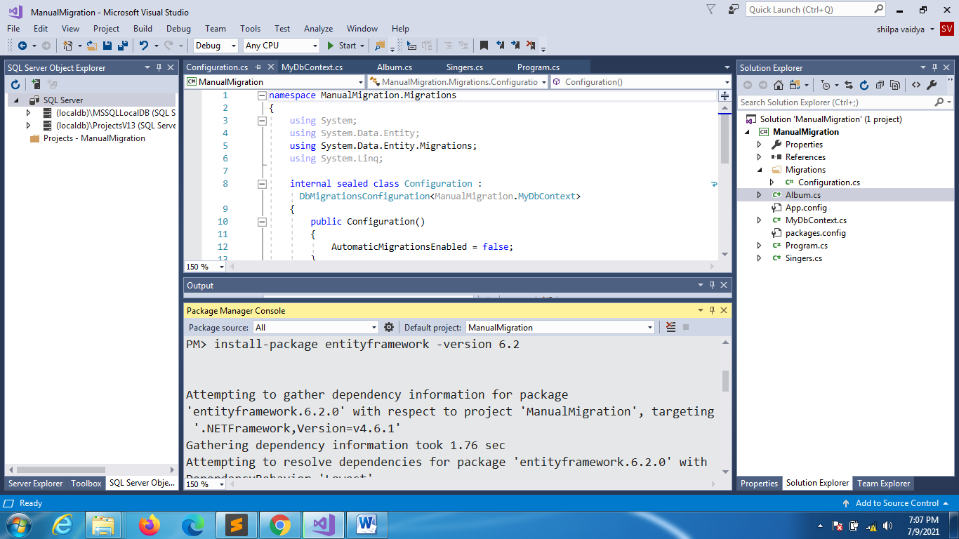

using System;

using System.Collections.Generic;

using System.Linq;

using System.Text;

using System.Threading.Tasks;

namespace ManualMigration

{

class Singers

{

public int SingersId { get; set; }

public string Singername { get; set; }

public int age { get; set; }

//add this change

public string email { get; set; }

//albums

public virtual ICollection<Album> Albums { get; set; }

}

}

**Above operation won’t be allowed hence**

PACKAGE MANAGER - >(ADDMIGRATION)

**PM> add-migration update1**

**UnderMigrations with timestamp the below details will be created**

namespace ManualMigration.Migrations

{

using System;

using System.Data.Entity.Migrations;

public partial class update3 : DbMigration

{

public override void Up()

{

AddColumn("dbo.Singers", "email", c => c.String());

}

public override void Down()

{

DropColumn("dbo.Singers", "email");

}

}

}

**CHANGE EXTRA THINGS TO THE SAME FILE**

namespace ManualMigration.Migrations

{

using System;

using System.Data.Entity.Migrations;

public partial class update3 : DbMigration

{

public override void Up()

{

AddColumn("dbo.Singers", "email", c => c.String(defaultValue:"aaa@gmail.com"));

}

public override void Down()

{

DropColumn("dbo.Singers", "email");

}

}

}

**To update changes**

**PM>update-database -verbose**

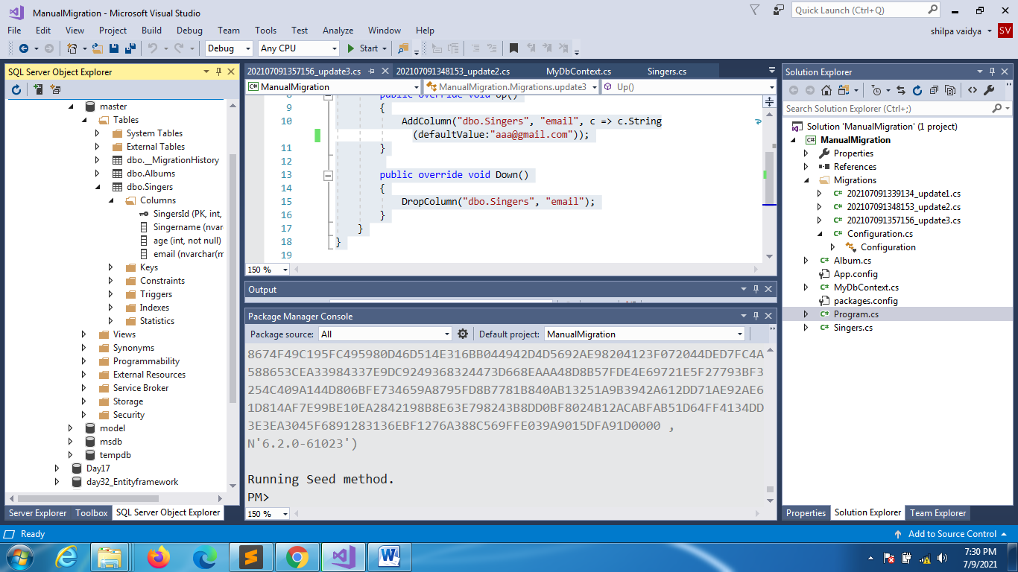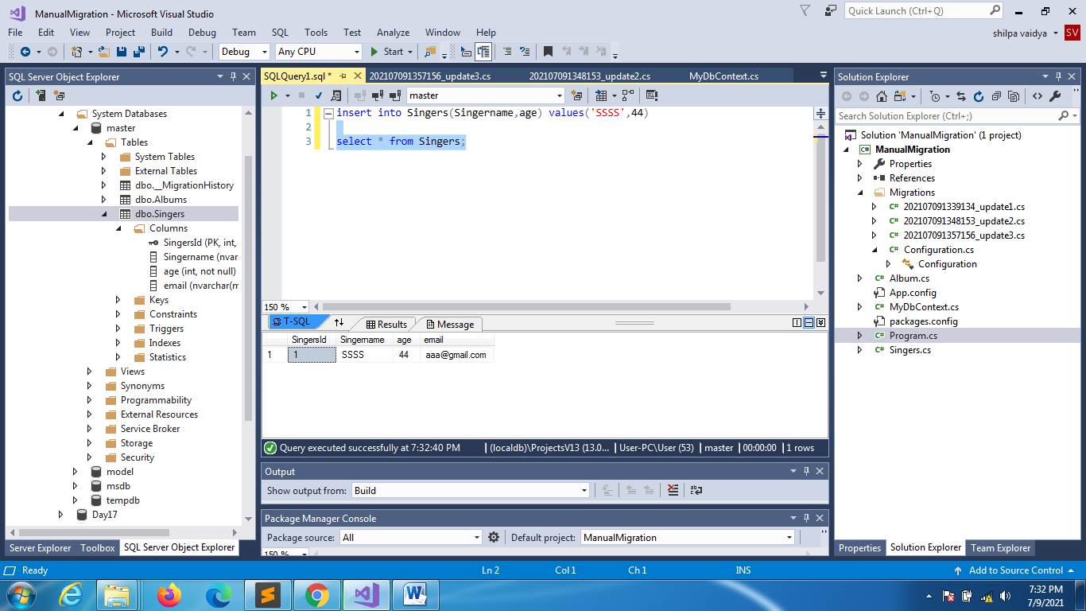

**Add** Sponsors.cs

using System;

using System.Collections.Generic;

using System.Linq;

using System.Text;

using System.Threading.Tasks;

namespace ManualMigration

{

class Sponsors

{

public int SponsorsId { get; set; }

public string SponsorsName { get; set; }

}

}

**MyDbContext**

using System;

using System.Data.Entity;

namespace ManualMigration

{

class MyDbContext:DbContext

{

public MyDbContext() : base("name=mydb")

{

}

public virtual DbSet<Singers> Singers { get; set; }

public virtual DbSet<Album> Albums { get; set; }

public virtual DbSet<Sponsors> Sponsors { get; set; }

}

}

**Package manager**

add-migration update2

it will create a new file with timestamp under migrations folder

This file will be created

namespace ManualMigration.Migrations

{

using System;

using System.Data.Entity.Migrations;

public partial class update4 : DbMigration

{

public override void Up()

{

CreateTable(

"dbo.Sponsors",

c => new

{

SponsorsId = c.Int(nullable: false, identity: true),

SponsorsName = c.String(),

})

.PrimaryKey(t => t.SponsorsId);

}

public override void Down()

{

DropTable("dbo.Sponsors");

}

}

}

Run the below in package manager

update-database -verbose

**based on the changes**

**rollback**

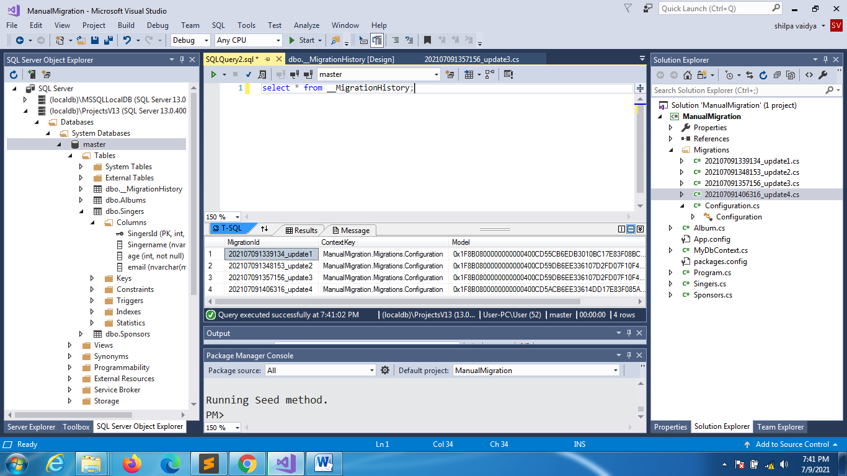

**Your changes will be reflected in migration history**

**Use target migration**

PM> update-database -targetmigration 202107091339134_update1

Latest table sponsors table will be dropped and it will rollback to update 1